Introduction to Cricut

To create an account:

<https://shop.cricut.com/en_us/customer/account/create/>

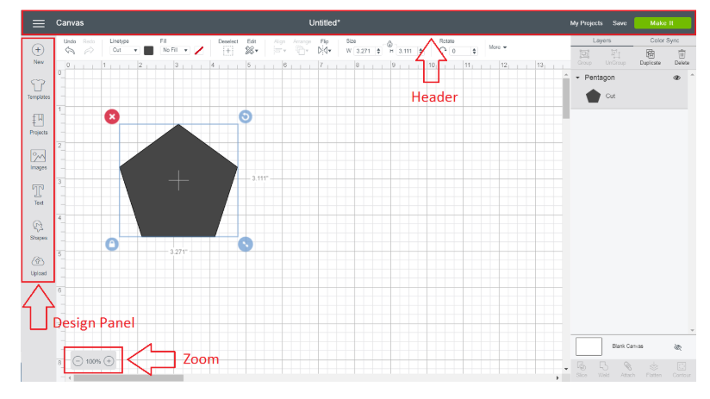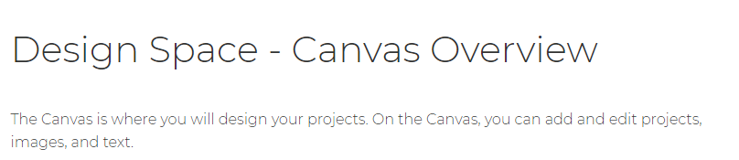

The following information was extracted from <https://help.cricut.com/hc/en-us>

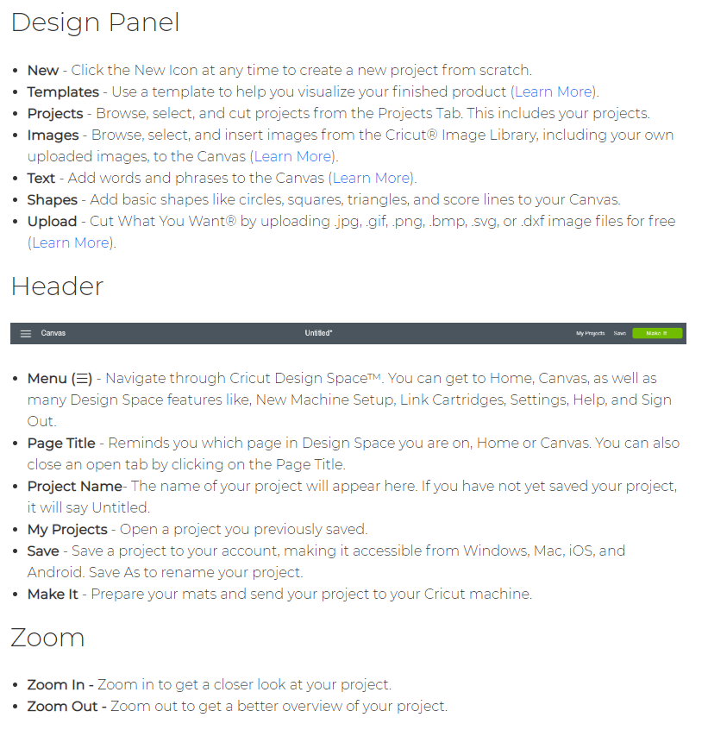

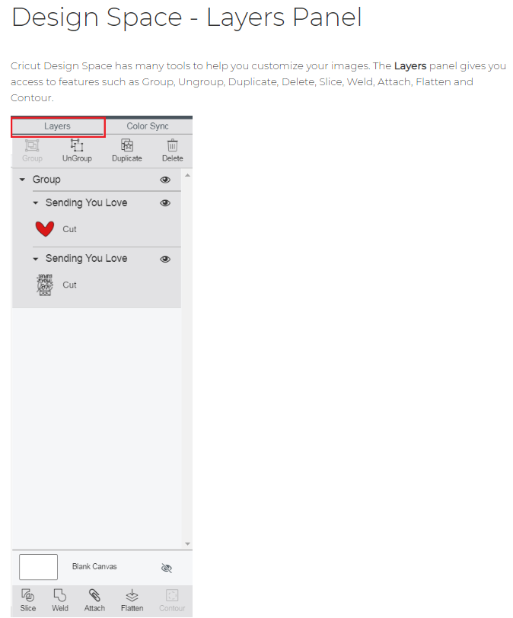

The following information was extracted from <https://help.cricut.com/hc/en-us>

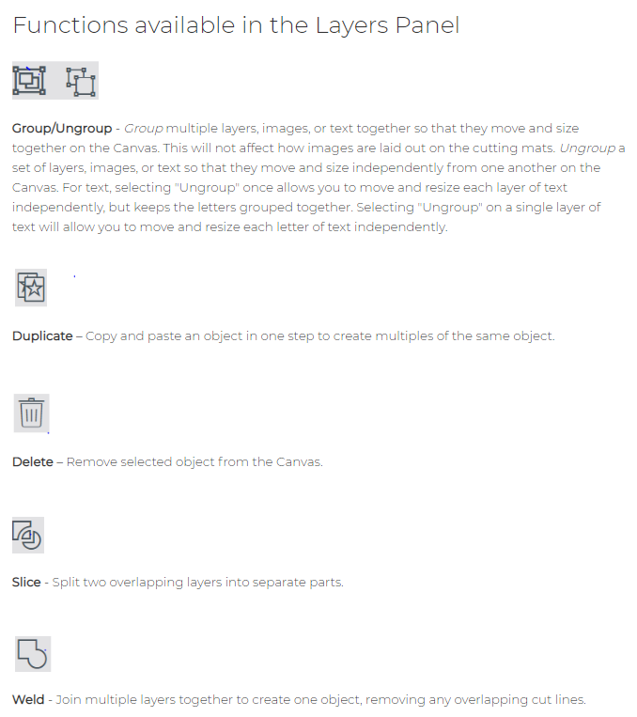

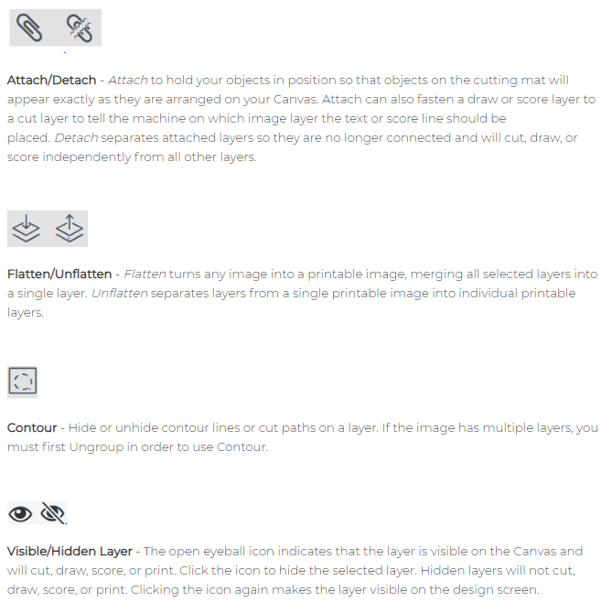

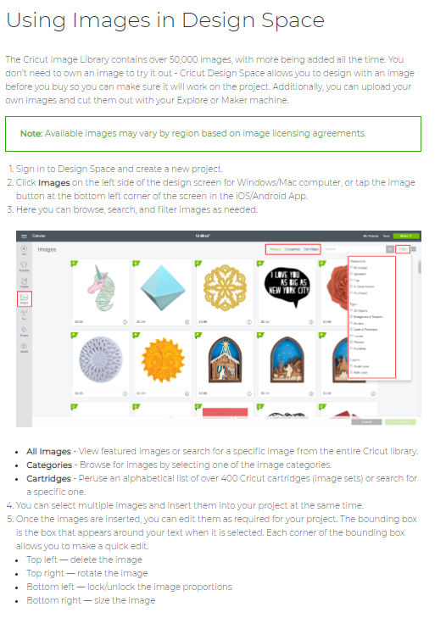

The following information was extracted from <https://help.cricut.com/hc/en-us>

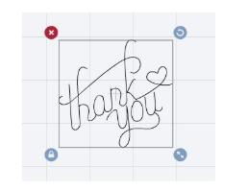

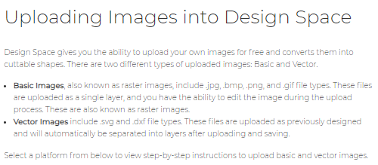

The following information was extracted from <https://help.cricut.com/hc/en-us>

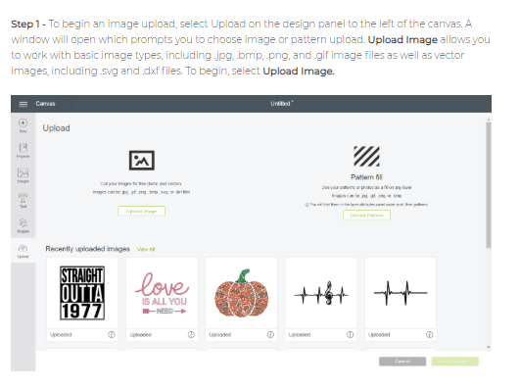

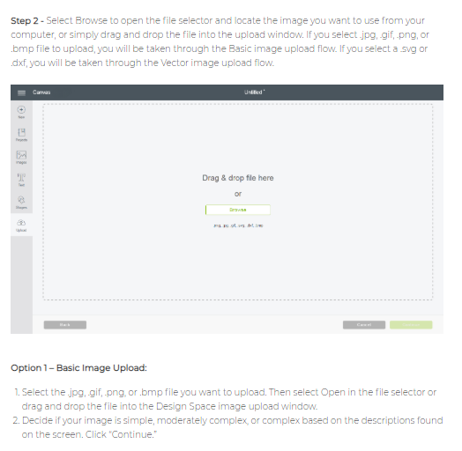

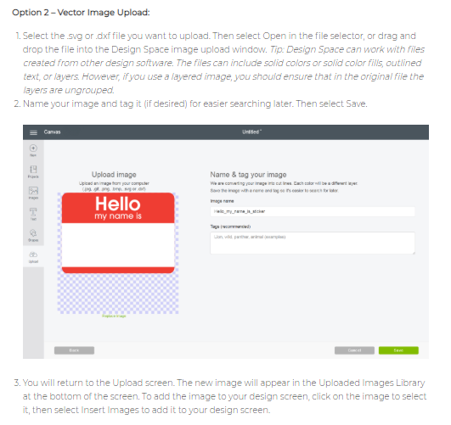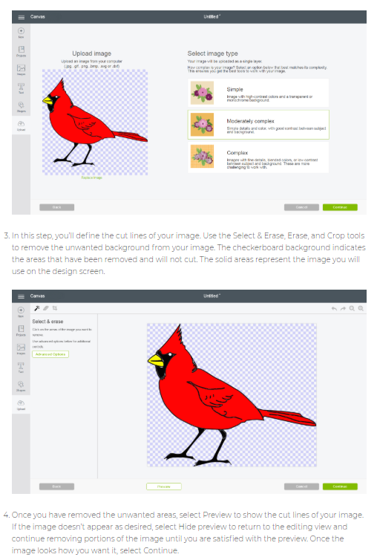

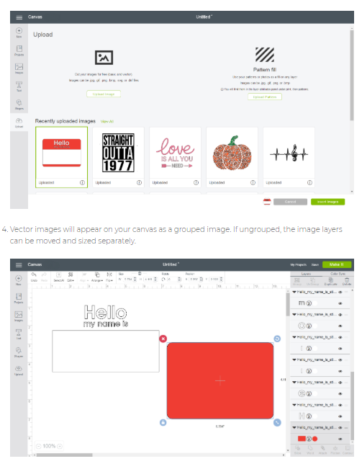

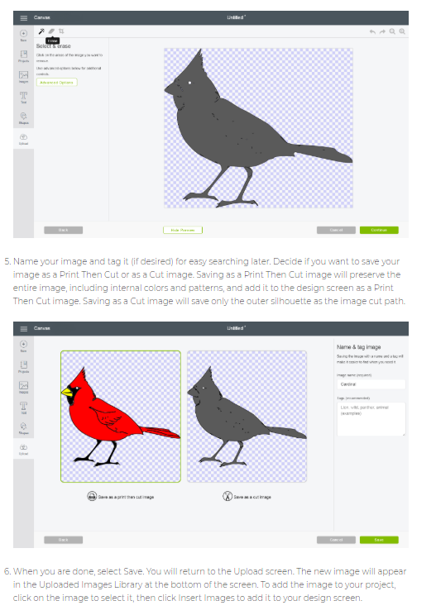

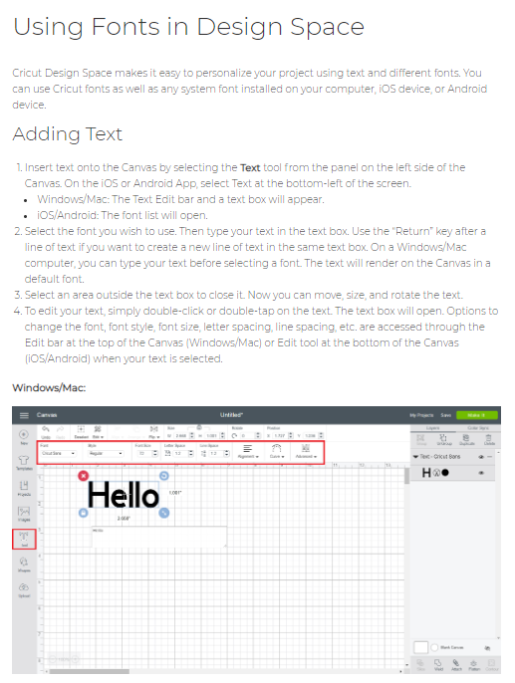

The following information was extracted from <https://help.cricut.com/hc/en-us>

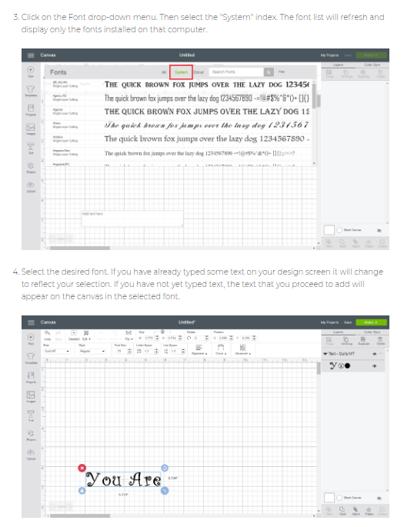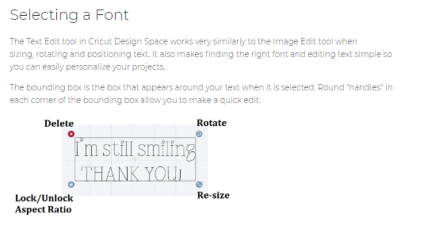

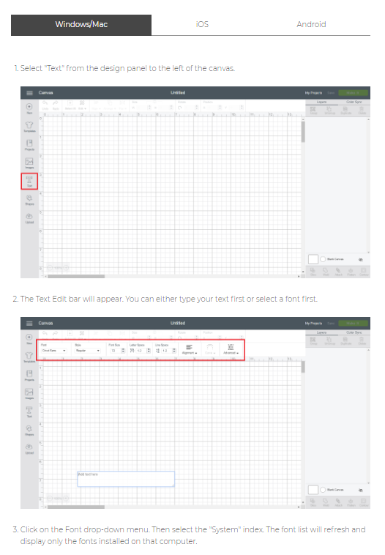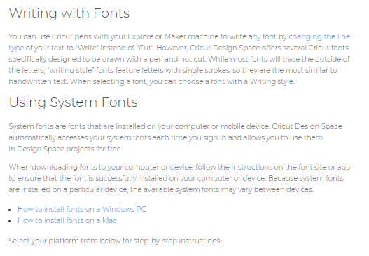



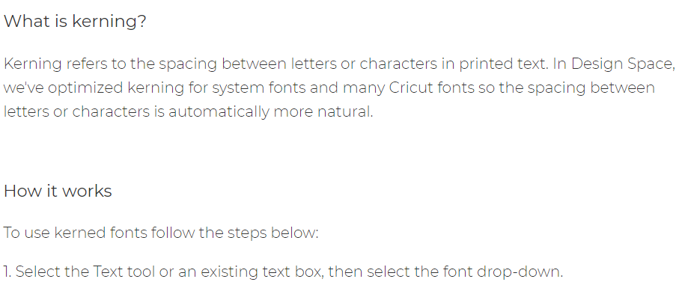

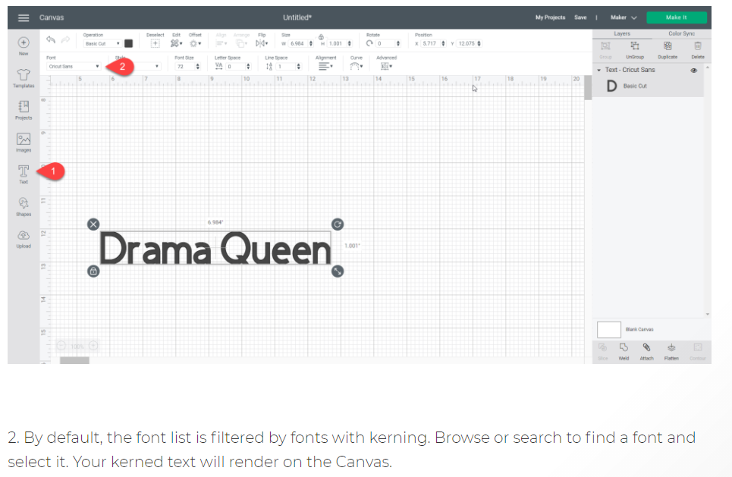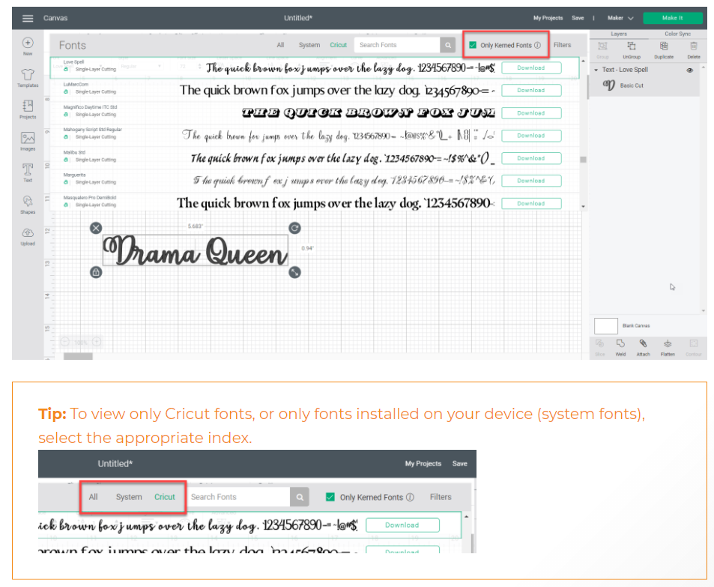

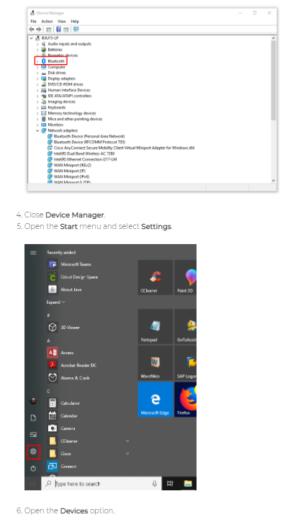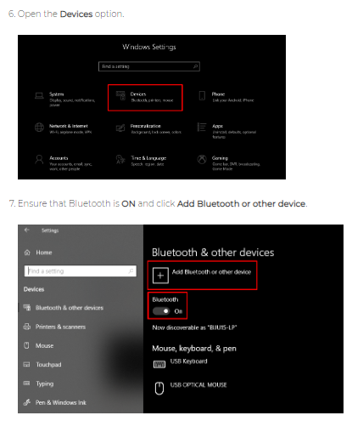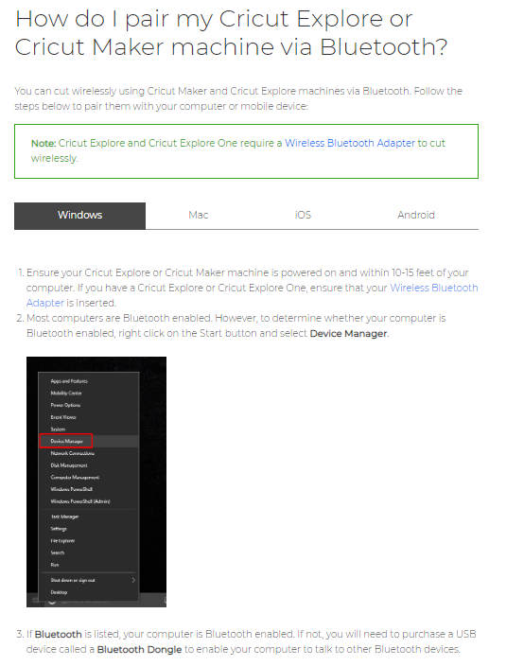

The following information was extracted from <https://help.cricut.com/hc/en-us>

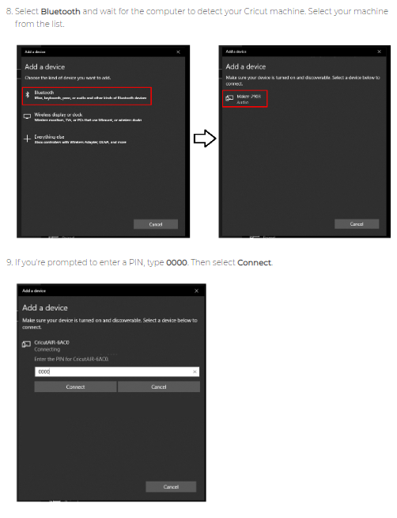

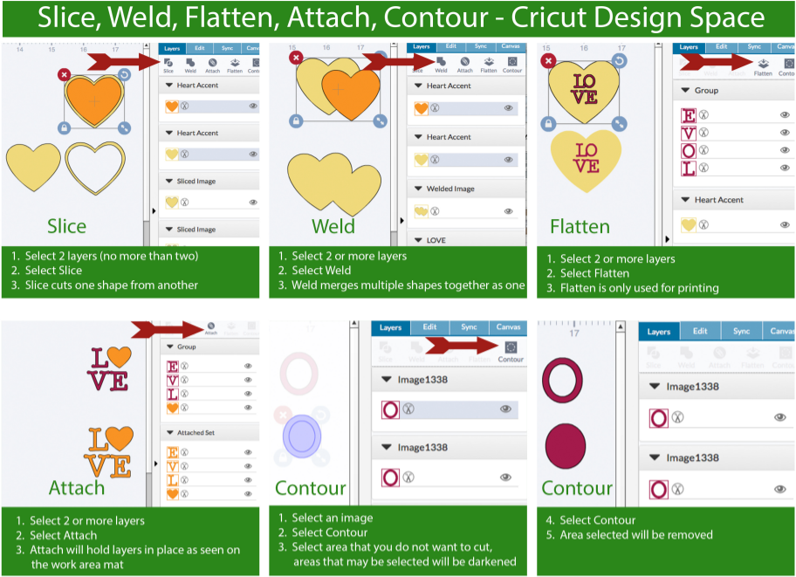

How to cut your project

1. Click the “**Make it**” button in Design Space
2. Select type of material you are cutting in Design Space
3. Place your material on the correct mat
   * Blue mat-paper
   * Green mat-cardstock and vinyl

\**You can manipulate what you are cutting on the screen’s mat to maximize use of materials*

1. Place mat up to machine and follow on screen instructions

***\*\*If there is an issue during cutting, press the stop button.***

Additional resources

* <https://help.cricut.com>: for helpful info and videos
* <https://www.youtube.com/OfficialCricut>: official Cricut You Tube Channel
* <https://Dafont.com>: free downloadable fonts
* <https://LoveSVG.com>: free downloadable images
* Facebook: many groups/pages related to Cricut